Parish Emblem Award 2026

ENTRY FORM

Name of Parish:

---------------------------------------------------------------------------------------------------------------------------------------------------

Population as stated on the electoral roll -------------------------------------------------------------------------------------

Contact Name ----------------------------------------------------------------------------------------------------------

Title ----------------------------------------------------------------------------------------------------------

Address ----------------------------------------------------------------------------------------------------------

Telephone ----------------------------------------------------------------------------------------------------------

Email -------------------------------------------------------------------------------------------------------------------

Deadline to enter: Friday 24th April 2026 Return to: cumbriainbloom@outllook.com

Entry fee: £30.00

Please note that entry fees must be paid at the time of entry.

Our preferred method of payment is via BACS:

Cumbria in Bloom
Account Number: 40098841
Sort Code: 20-66-97

Alternatively, cheques should be made payable to Cumbria in Bloom and posted to the address below. If you need an invoice or receipt, please advise.

Assessments will take place anonymously during the period of 29th June – 24th July 2026 by one or more of our assessors.

Once complete, please return your form no later than Friday, 24th April 2026, to cumbriainbloom@outlook.com

Criteria for Our Judges

Our judges want you to get the best experience out of entering our competition, so here is a helpful guide on what they will be looking for.

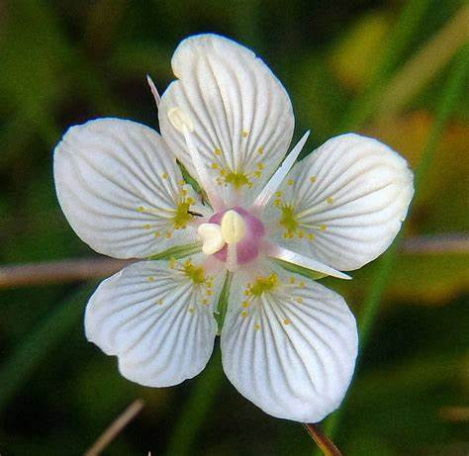
Parnassia palustris emblems
Max 5 emblems

Overall impressions of horticultural impact
Cleanliness
Maintenance and provision of public amenities

Photo credit to Cumbria Wildlife Trust

